Table 1 of the supplementary data
Principal investigators of the study and participating centers
Principal investigators | Hospital
Pablo García-Pavía | Hospital Universitario Puerta de Hierro, Madrid
José Manuel García-Pinilla | Hospital Virgen de la Victoria, Málaga
Jorge Álvarez | Hospital Son Llàtzer, Palma de Mallorca
Javier Carrasco | Hospital Juan Ramón Jiménez, Huelva
Domingo Pascual-Figal | Hospital Clínico Universitario Virgen de la Arrixaca, Murcia
Gonzalo Barge-Caballero | Complejo Hospitalario Universitario de A Coruña, A Coruña
Javier López Díaz | Hospital Clínico Universitario de Valladolid, Valladolid
José González-Costello | Hospital Universitario de Bellvitge, L'Hospitalet de Llobregat
Javier Santesmases | Hospital Universitario Germans Trias i Pujol, Badalona
Julio Núñez-Villota | Hospital Clínico Universitario Valencia, Valencia
María Ángeles Espinosa | Hospital General Universitario Gregorio Marañón, Madrid
Miguel Ángel Aibar | Hospital Clínico Universitario Lozano Blesa, Zaragoza
Beatriz Díaz Molina | Hospital Universitario Central de Asturias, Oviedo
Antonio García-Quintana | Hospital Universitario de Gran Canaria Doctor Negrín, Las Palmas de Gran Canaria
Mª Victoria Mogollón | Hospital San Pedro Alcántara, Cáceres
Juan José Gavira-Gómez | Clínica Universidad de Navarra, Pamplona
Elena Sufrate | Hospital San Pedro de Logroño, Logroño
Francisco J. Medrano | Hospital Virgen del Rocío, Sevilla
Ainara Lozano-Baamonde | Hospital de Basurto, Bilbao
Alberto Gómez-Pérez | Hospital General Albacete, Albacete

Table 2 of the supplementary data
Summary of studies evaluating the prevalence of ATTR-CA as a cause of heart failure
Reference | Type of study | Patients, No. | Inclusion criteria |  |  |  | ATTR-CA prevalence | Comments
 |  |  | LVH | HF | Age, y | Others
García-Pavía P, et al. 2024  (present study) | Prospective  Multicenter | 387 | ≥ 12mm | HFpEF | ≥ 50 | Ambulatory and hospitalized; prior HF hospitalization | 16.8% (13.4% ATTRwt; 1.0% ATTRv; 2.3% untyped).  Increases with age. | From cardiology (64%), internal medicine (9%) or both (27%).  Mainly noninvasive diagnosis (99mTc-DPD/PYP/HMDP scintigraphy + hematologic test + genetic testing).  50% in NYHA I-II.
Spaccavento A, et al.²² | Prospective  Single-center | 103 |  | Acute HF | ≥ 60 | Admitted patients | 15.5% | Mainly noninvasive diagnosis (99mTc-HDMP-SPECT + hematologic test + genetic testing).
Tubben A, et al.²³ | Prospective  Multicenter | 104 | ≥ 11mm | HFmrEF and HFpEF |  | Hospitalized patients | 4.8% (all ATTRwt)  13.2% among HFpEF | Mainly noninvasive diagnosis (99mTc-HDP-SPECT-CT + hematologic test + genetic testing).  No ATTR-CA patient with NYHA I; 60% NYHA II.
Ruiz-Hueso R, et al.¹⁸ | Prospective  Multicenter | 453 | > 12mm | HF | ≥ 65 | NYHA II-IV, diuretics 6 months.  Ambulatory & hospitalized | 16.8% (7.9% ATTRwt; 0.9% ATTRv; 7.9% untyped).  Increases with age. | Mainly noninvasive diagnosis (99mTc-DPD/PYP/HMDP scintigraphy-SPECT-CT + hematologic test + genetic testing).  Among all CA patients, 26.5%with HF < 50%.  Among all CA patients, 31% NYHA II-IV.
Goland S, et al.⁷ | Prospective  Single-center | 75 |  | HF (< 50%) |  | Outpatients | 9.3% (all ATTRwt).  Trend for higher prevalence of men. | Mainly noninvasive diagnosis (99mTc-PYP-SPECT + hematologic test + genetic testing).  No ATTR-CA patient with NYHA I; 15% NYHA II.
Devesa A, et al.¹⁷ | Prospective  Single-center | 58 | <12mm | HFpEF | ≥ 18 | Admitted patients | 5.2% (all ATTRwt) | Mainly noninvasive diagnosis (99mTc-DPD-SPECT-CT + hematologic test + genetic testing).  33.3% of ATTR-CA in NYHA I; 66.6% in NYHA II.
AbouEzzeddine OF, et al.¹⁴ | Prospective  Population-based cohort | 1235  (286 screening cohort) | ≥ 12mm | HFpEF  (> 40%) | ≥ 60 | Medical records | No screening cohort: 1.3%.  Screening cohort: 6.3% (~89% ATTRwt).  Increases with age.  Significantly higher in men. | Mainly noninvasive diagnosis (pyrophosphate scintigraphy-SPECT-CT + hematologic tests + genetic testing).
Lindmark K, et al.¹² | Prospective  Single-center | 174 | > 14 mm | HF |  | Patients with ICD-10 codes invited to participate | 14.4 %* (all ATTRwt) | From cardiology and internal medicine.  *48% diagnosed prior to study inclusion.  46% of ATTR-CA patients with EF < 50%.  Mainly noninvasive diagnosis (99mTc-DPD-SPECT-CT + hematologic test + genetic testing).
Hahn VS, et al.¹³ | Prospective  Single-center | 108 |  | HFpEF |  | Ambulatory patients | 10.2% (6.5% ATTRwt; 3.7 ATTRv) | Endomyocardial biopsy.  No ATTR-CA patient with NYHA I; 33.6% NYHA II.
López Sainz A, et al.²⁴ | Retrospective  Single-center | 28 | ≥ 12mm | HF  (< 50%) |  | Medical records | 11% (all ATTRwt) | Mainly noninvasive diagnosis (99mTc-DPD + genetic testing).  No ATTR-CA patient with NYHA I; 96% NYHA III-IV.
Bennani Smires Y, et al.¹⁵ | Prospective  Single-center | 49 |  | HFpEF  (> 45%) | > 65 | Ambulatory patients | 18.4% (all ATTRwt) | Mainly noninvasive diagnosis (99mTc-DPD + genetic testing).  No ATTR-CA patient in NYHA I; 56% NYHA II.
González-López E, et al.¹⁶ | Prospective  Single-center | 120 | ≥ 12mm | HFpEF | ≥ 60 | NYHA II-IV  Admitted patients | 13.3% (all ATTRwt) | From cardiology (53%) and internal medicine (47%).  Mainly noninvasive diagnosis (99mTc-DPD + genetic testing).
Mohammed SF, et al.²⁵ | Retrospective  Multicenter | 109 |  | HFpEF (> 40%) |  | Autopsy | 17%* (all ATTRwt)  Increases with age.  Significantly higher in men. | *Prevalence of amyloid deposition in autopsy specimens. No mention on medical records of suspicion of CA.  No diagnosis in patients < 65 years.
ATTR, transthyretin amyloidosis; ATTR-CA, patients with confirmed diagnosis of ATTR-CA; ATTRv, hereditary transthyretin amyloidosis; ATTRwt, wild type transthyretin amyloidosis; CTS, carpal tunnel syndrome; CT, computed tomography; EF, ejection fraction; HF, heart failure; HFmrEF, heart failure with mid-range ejection fraction; HFpEF, heart failure with preserved ejection fraction; ICD-10, International Classification of Diseases, tenth revision; LVH, left ventricular hypertrophy; NYHA, New York Heart Association; SPECT, single-photon emission computed tomography.

In bold, studies with prevalence data in HFpEF population.

Figure 1 of the supplemetary data
Scenarios according to diagnostic tests results. Only data from patients with both scintigraphy and hematologic tests are shown. There were 33 patients without scintigraphy, 2 without hematologic tests, and 276 patients with Grade 0 without hematologic tests and are not presented. *Includes grades 0 per local reading, as these scintigraphs were not centrally analyzed, and 4 positive scintigraphs at local reading that were reclassified. **Includes grades 0 per local reading, as these scintigraphs were not centrally analyzed, and 2 positive scintigraphs at local reading that were reclassified.

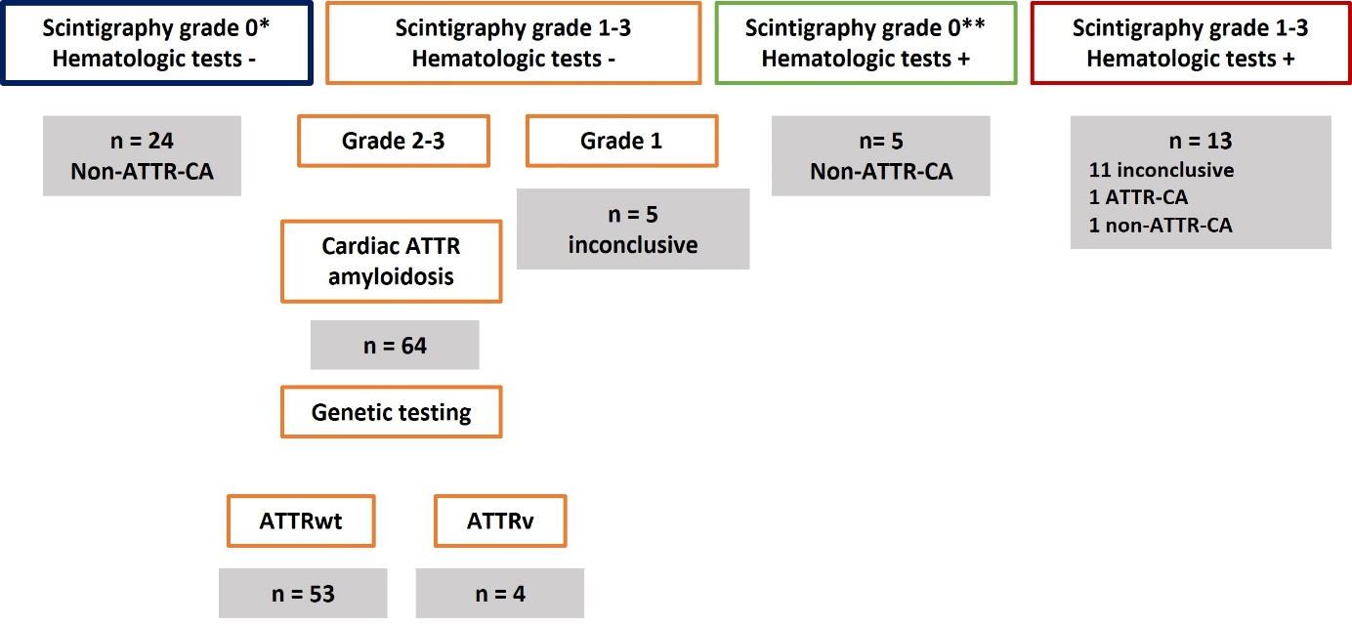

Correcciones a la figura
Cambiar “N = “ a “n =”. Hecho.

