SUPPLEMENTARY DATA

List of participating centers
- Complejo Asistencial Universitario de León, León, Spain
- Hospital Universitario Virgen de la Victoria, Málaga, Spain
- Hospital Clinic, Barcelona, Spain
- Hospital Clínico Universitario de Valladolid, Valladolid, Spain
- Hospital Reina Sofía de Córdoba, Córdoba, Spain
- Hospital Puerta de Hierro Majadahonda, Majadahonda, Madrid, Spain
- Hospital Central de Asturias, Oviedo, Asturias, Spain
- Hospital Clínico Universitario de Salamanca, Salamanca, Spain
- Hospital Clínico San Carlos, Madrid, Spain
- Hospital Clínico Universitario de Valencia, Valencia, Spain
- Hospital Universitario de Basurto, Bilbao, Vizcaya, Spain
- Hospital La Fe de Valencia, Valencia, Spain
- Complejo Hospitalario Universitario de Vigo, Vigo, Pontevedra, Spain
- Hospital Germans Trias i Pujol, Barcelona, Spain

Definitions of technical success and device success
Mitral Valve Academic Research Consortium definitions

Technical success (measured at exit from the catheterization laboratory)
All of the following must be present:
- Absence of procedural mortality; and
- Successful access, delivery, and retrieval of the device delivery system; and
- Successful deployment and correct positioning of the first intended device; and
- Freedom from emergency surgery or reintervention related to the device or access procedure.

Device success (measured at 30 days and at all later postprocedural intervals).
All of the following must be present:
- Absence of procedural mortality or stroke; and
- Proper placement and positioning of the device; and
- Freedom from unplanned surgical or interventional procedures related to the device or access procedure; and
- Continued intended safety and performance of the device, including:
  - No evidence of structural or functional failure (see table 11, part I)
  - No specific device-related technical failure issues or complications (see table 11, part II)
  - Reduction of MR to either optimal or acceptable levels without significant mitral stenosis (ie, postprocedure EROA is ≥ 1.5 cm² with a transmitral gradient < 5 mmHg), and with no more than mild (1+) paravalvular MR (without associated hemolysis). MR reduction is considered optimal when postprocedure MR is reduced to trace or absent. MR reduction is considered acceptable when postprocedure MR is reduced by at least 1 class or grade from baseline and to no more than moderate (2+) in severity.

Reference:
Stone GW, Adams DH, Abraham WT, et al. Clinical Trial Design Principles and Endpoint Definitions for Transcatheter Mitral Valve Repair and Replacement: Part 2: Endpoint Definitions: A Consensus Document From the Mitral Valve Academic Research Consortium. J Am Coll Cardiol. 2015;66:308-321.
Table S1. Oncological characteristics of the survivors

Cancer survivors (n = 163)
Age at M-TEER, y | 74.3 ± 9.3
Female | 62 (38.0)
Time since cancer diagnosis, y | 7 [3-17]
Type  Breast  Leukemia/lymphoma  Prostate  Colorectal  Lung  Kidney  Bladder  Gynecologic  Melanoma  NMSC  Thyroid  Other | 34 (20.9)  32 (19.6)  21 (12.9)  20 (12.3)  10 (6.1)  7 (4.3)  7 (4.3)  6 (3.7)  5 (3.1)  4 (2.5)  4 (2.5)  13 (8.0)
Solid tumors  Nonmetastatic  Metastatic | 121 (93.8)  8 (6.2)
Chemotherapy  Anthracyclines  Anti-HER2  Other | 47 (30.3)  13 (8.4)  23 (14.8)
Chest radiotherapy  Left-sided  Mediastinal  Other | 24 (15.5)  9 (5.8)  20 (12.9)
CTRCD  LVEF 40%-49%  LVEF < 40% | 14 (8.8)  30 (18.9)
M-CTRCD, cancer therapy related cardiac dysfunction; NMSC, nonmelanoma skin cancer; TEER, mitral transcatheter edge-to-edge repair.
Continuous variables are presented as mean ± standard deviation or as mean [interquartile range]. Categorical variables are presented as percentages of available data (there were 8 missing values for chemotherapy, radiotherapy and 4 missing values for CTRCD).
Table S2. Between-group comparison of technical and device success stratified by mitral regurgitation etiology

 | Cancer survivors | Control | P
Functional
Technical success | 83 (97.6) | 88 (98.9) | .614
Device success | 73 (85.9) | 84 (94.4) | .059
Organic
Technical success | 48 (96.0) | 54 (96.4) | > .999
Device success | 44 (88.0) | 46 (82.1) | .400
Mixed
Technical success | 27 (96.4) | 17 (94.4) | > .999
Device success | 27 (96.4) | 17 (94.4) | > .999

The data are presented as No. (%).

Table S3. Variance inflation factor values

Predictor | VIF
Diabetes mellitus | 1.07
Anemia | 1.10
EuroSCORE II | 1.09
Hematologic malignancies | 1.24
Mediastinal radiotherapy | 1.29

VIF, variance inflation factor. All VIF values were below the threshold of 5, indicating low multicollinearity among the risk factors.

Figure S1. Primary endpoint stratified by mitral regurgitation etiology and group.
CS, cancer survivors; C, control group; DMR, degenerative mitral regurgitation; MMR, mixed mitral regurgitation; FMR, functional mitral regurgitation; HFH, heart failure hospitalization.

Correcciones a la figura 1
Indicar valores de P en formato REC, P = .036
P for interaction = .516
Cambiar “Follow-Up (Months) a “Follow-up (months) x 2

Figure S2. Schoenfeld residual plot and test

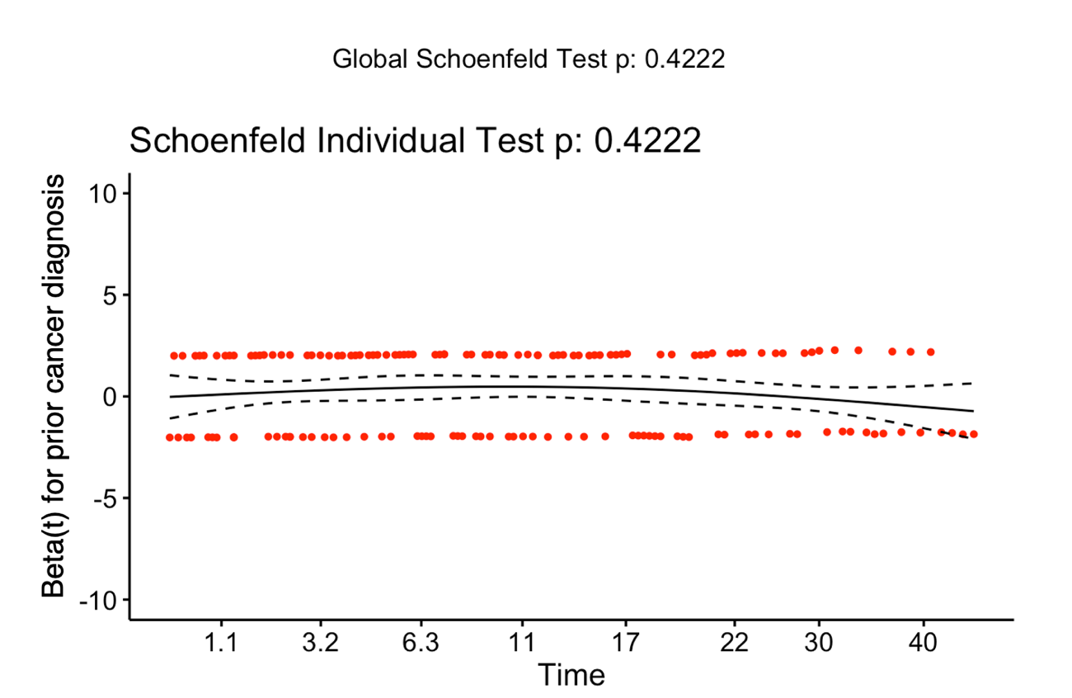
No systematic trend over time was observed in the Schoenfeld residual plot, supporting the proportional hazards assumption. Schoenfeld residuals test P = .422 also supports that the proportional hazards assumption is not violated.

Correcciones a la figura 2
Indicar valores de P en formato REC, P = .4222
Poner mayúscula solo al principio de la frase: “Schoenfeld individual test”, y Global Schoenfeld test”
Eje vertical: Cambiar guión por signo menos

Figure S3. Schoenfeld residual plots and tests

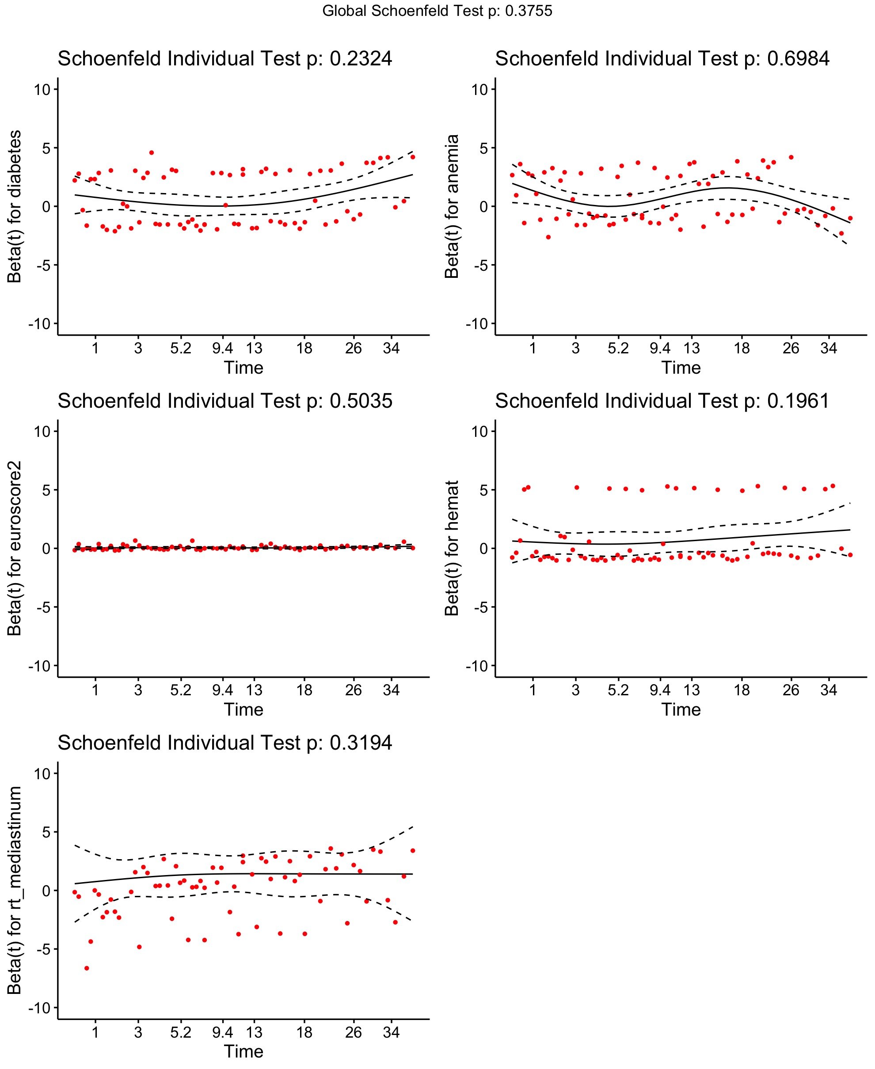

Scaled Schoenfeld residual plots for each covariate (diabetes mellitus, anemia, EuroSCORE II, hematologic malignancies and mediastinal radiotherapy). No systematic trends over time were observed, supporting the proportional hazards assumption. Schoenfeld residuals tests P > .05 also support that the proportional hazards assumption is not violated.

Correcciones a la figura 3
Indicar valores de P en formato REC, P = .3755 (x 5)
Poner mayúscula solo al principio de la frase: “Schoenfeld individual test”, y Global Schoenfeld test”
Eje vertical: Cambiar guión por signo menos

