SUPPLEMENTARY DATA
Table 1 of the supplementary data. Univariate and multivariate analysis of predictors urinary sodium
−

 | Univariate |  | Multivariate
 | ß | P | ß | P
Age | −0.064 (−0.125 to −0.003) | .038
Systolic BP | 0.381 (0.209−0.554) | < .001 | 0.306 (0.132-0.480) | .001
De novo HF | 16.171 (7.679 to 24.663) | < .001
Previous furosemide | −13.453 (−22.269 to −4.638) | .003
Creatinine | −13.212 (−23.617 to −2.807) | .013
Urea | −0.188 (−0.330 to −0.047) | .009 | −0.148 ((−0.285 to (−0.105) | .035
Sodium | 0.548 (0.074 to 1.023) | .024
NT-proBNP | −0.0003 (−0.0007 to −0.00001) | .059
Congestion score | −2.681 (−5.210 to −0.151) | .038

BP, blood pressure; HF, heart failure, NT-proBNP, N-terminal pro-B-type natriuretic peptide.

Figure 1 of the supplementary data. Association of urinary sodium, as a continuous variable, and the hazard ratio for the main combined event using restricted cubic spline.
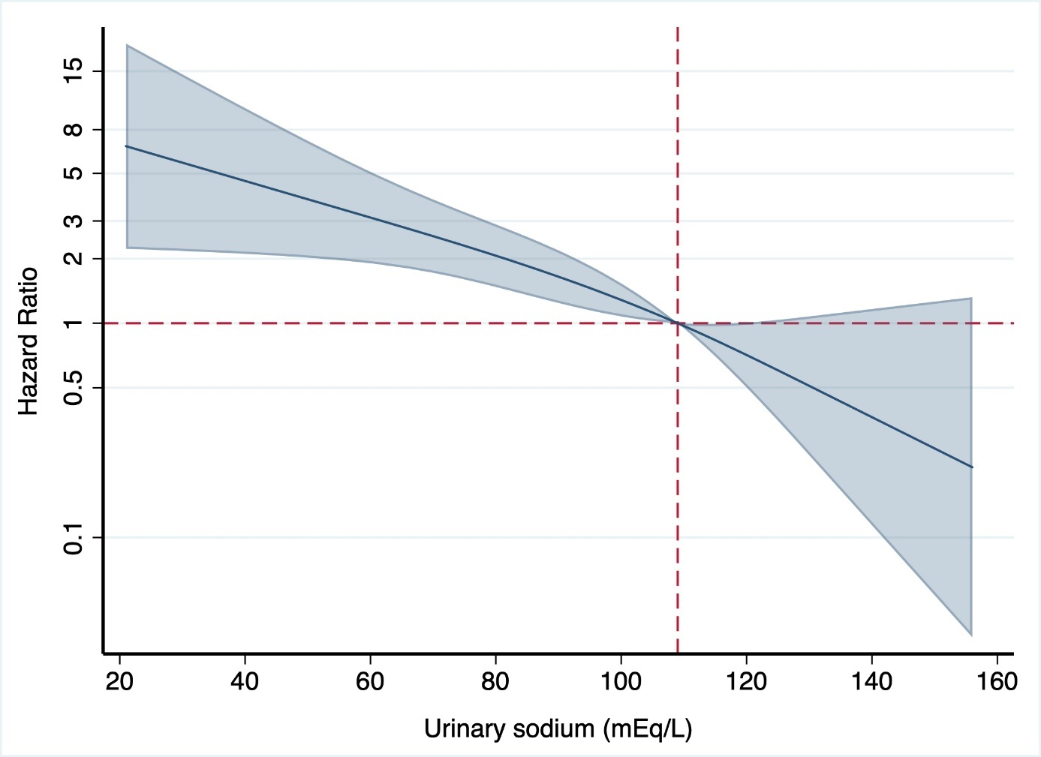

Cambiar “Hazard Ratio” a “Hazard ratio”

