SUPPLEMENTARY DATA
Table S1. Distribution of pathogenic/likely pathogenic variants according to functional gene groups in the overall cohort

Functional gene groups | Frequency | Percent
Cytoskeleton/Z-disk genes (DMD, FLNC, JHP2) | 30 | 9.87
Desmosomal genes (DSC2, DSG2, DSP, PKP2) | 32 | 10.53
Nuclear envelope genes (EMD, LMNA, TMEM43) | 40 | 13.16
Motor sarcomeric genes (ACTC1, MYBPC3, MYH7, TNNI3, TNNT2, TPM1) | 46 | 15.13
TTN gene | 107 | 35.20
Others (BAG3, PLN, RBM20, PRDM16, NKX2-5, FKTN) | 49 | 16.12
Total | 304 | 100.00

Functional gene groups |  | Frequency | Percent
Cytoskeleton/ Z-disk genes |  | 30 | 9.87
 | DMD | 13 | 4.28
 | FLNC | 16 | 5.26
 | JPH2 | 1 | 0.33
Desmosomal genes |  | 32 | 10.53
 | DSC2 | 1 | 0.33
 | DSG2 | 3 | 0.99
 | DSP | 27 | 8.88
 | PKP2 | 1 | 0.33
Nuclear envelope genes |  | 40 | 13.16
 | EMD | 1 | 0.33
 | LMNA | 36 | 11.84
 | TMEM43 | 3 | 0.99
Motor sarcomeric genes |  | 46 | 15.13
 | MYBPC3 | 11 | 3.62
 | MYH7 | 11 | 3.62
 | TNNT2 | 13 | 4.28
 | TPM1 | 7 | 2.30
 | ACTC1 | 1 | 0.33
 | TNNI3 | 3 | 0.99
TTN gene |  | 107 | 35.20
Others |  | 49 | 16.12
 | BAG3 | 23 | 7.57
 | RBM20 | 22 | 7.24
 | PLN | 1 | 0.33
 | PRDM16 | 1 | 0.33
 | NKX2-5 | 1 | 0.33
 | FKTN | 1 | 0.33
Total |  | 304 | 100.00

Table S2. Medical treatment and dose according to left ventricular reverse remodeling at mid-term (n = 711)

 | Total (n=711) | With LVRR (n = 307) | Without LVRR (n = 404) | P
Baseline
β-blocker | 583 (83.29) | 265 (86.32) | 318 (80.92) | .057
Half dose | 255 (43.74) | 108 (40.75) | 147 (46.23) | .185
ACE inhibitor/ARB | 579 (82.71) | 246 (80.13) | 333 (84.73) | .110
Half dose | 257 (44.39) | 118 (47.97) | 139 (41.74) | .136
Sacubitril/valsartan | 50 (7.14) | 32 (10.42) | 18 (4.58) | .003
Half dose | 13 (26.00) | 8 (25.00) | 5 (27.78) | .830
MRA | 314 (44.86) | 161 (52.44) | 153 (38.93) | <.001
Half dose | 297 (94.59) | 153 (95.03) | 144 (94.12) | .721
Mid-term
β-blocker | 617 (90.60) | 282 (93.69) | 335 (88.16) | .014
Half dose | 368 (59.64) | 184 (65.25) | 184 (54.93) | .009
ACE inhibitor/ARB | 524 (77.06) | 215 (71.67) | 309 (81.32) | .003
Half dose | 307 (58.70) | 140 (65.12) | 167 (54.22) | .013
Sacubitril/valsartan | 122 (17.99) | 74 (24.67) | 48 (12.70) | <.001
Half dose | 85 (69.67) | 55 (74.32) | 30 (62.50) | .165
MRA | 413 (61.00) | 199 (66.33) | 214 (56.76) | .011
Half dose | 401 (97.09) | 193 (96.98) | 208 (97.20) | .898

ACEi, angiotensin-converting enzyme inhibitors; ARB, angiotensin receptor blocker; ARNI, angiotensin receptor/neprilysin inhibitor; MRA, mineralcorticoid receptor antagonist.
Values areexpressed as No. (%). Half dose= percentage of patients achieving at least 50% of target dose
Table S3. Medical treatment and dose at mid-term according to functional gene group

 | Total (n = 703) | Negative genotype  (n = 399) | Cytoskeleton/Z-disk (n = 30) | Desmosomal (n = 32) | Nuclear envelope (n = 40) | Motor sarcomeric (n = 46) | TTN (n = 107) | Other genes (n = 49) | P
β-blocker | 613 (90.68) | 356 (92.71) | 28 (93.33) | 28 (87.50) | 28 (75.68) | 38 (88.37) | 96 (93.20) | 39 (82.98) | .010
Half dose | 366 (59.71) | 219 (61.52) | 13 (46.43) | 14 (50.00) | 11 (39.29) | 24 (63.16) | 65 (67.71) | 20 (51.28) | .054
ACE inhibitor/ARB | 520 (77.04) | 293 (76.50) | 26 (86.67) | 26 (81.25) | 28 (75.68) | 33 (76.74) | 78 (75.73) | 36 (76.60) | .910
Half dose | 306 (58.96) | 187 (64.04) | 17 (65.38) | 7 (26.92) | 10 (35.71) | 19 (57.58) | 44 (56.41) | 22 (61.11) | .002
Sacubitril/valsartan | 121 (17.98) | 77 (20.16) | 3 (10.00) | 4 (12.50) | 2 (5.41) | 6 (13.95) | 21 (20.39) | 8 (17.39) | .236
Half dose | 84 (69.42) | 58 (75.32) | 3 (100) | 3 (75.00) | 2 (100) | 2 (33.33) | 11 (52.38) | 5 (62.50) | .114
MRA | 409 (60.86) | 231 (60.47) | 16 (55.17) | 18 (56.25) | 17 (45.95) | 30 ( 69.77) | 69 (66.99) | 28 (60.87) | .301
Half dose | 397 (97.07) | 223 (96.54) | 16 (100) | 18 (100) | 17 (100) | 30 ( 100) | 65 (94.20) | 28 (100) | .480

ACEi, angiotensin-converting enzyme inhibitors; ARB, angiotensin receptor blocker; ARNI, angiotensin receptor/neprilysin inhibitor; MRA, mineralcorticoid receptor antagonist.
Values are expressed as No. (%). Half dose= percentage of patients achieving at least 50% of target dose (target dose recommended in 2021 ESC Guidelines for the diagnosis and treatment of acute and chronic heart failure).¹⁵

Table S4. Outcomes and Events during follow-up according to left ventricular reverse remodeling at mid-term (n = 711)

 | Total (n = 711) | With LVRR (n =30 7) | Without LVRR (n = 404) | P
New onset AF | 71 (12.59) | 27 (10.67) | 44 (14.15) | .216
Stroke | 26 (3.66) | 7 (2.28) | 19 (4.70) | .088
Sustained ventricular arrhythmia | 51 (7.17) | 11 (3.58) | 40 (9.90) | .001
Appropriate ICD therapy | 47 (6.61) | 11 (3.58) | 36 (8.91) | .005
Aborted SCD | 7 (1.00) | 1 (0.33) | 6 (1.50) | .120
Heart transplant | 70 (9.85) | 10 (3.26) | 60 (14.85) | <.001
LVAD implantation | 19 (2.67) | 5 (1.63) | 14 (3.47) | .133
Composite MACE | 156 (21.94) | 35 (11.40) | 121 (29.95) | <.001
Composite ESHF | 97 (13.64) | 17 (5.54) | 80 (19.80) | <.001
Composite MVA | 79 (11.11) | 19 (6.19) | 60 (14.85) | <.001

AF, atrial fibrillation; ESHF, end-stage heart failure; HF, heart failure; ICD, implantable cardioverter-defibrillator; LVAD, left ventricular assist device; MACE, major adverse cardiovascular events; MVA, malignant ventricular arrhythmia; SCD, sudden cardiac death.
Values are expressed as No. (%).

Table S5. Outcomes and events according to left ventricular reverse remodeling at long-term

 | Total (n = 284) | Persistent recovery (n = 211) | Worsening LVEF (n = 73) | P
New onset AF | 27 (11.54) | 16 (8.94) | 11 (20.00) | .025
Stroke | 7 (2.46) | 3 (1.42) | 4 (5.48) | .054
Sustained ventricular arrhythmia | 11 (3.87) | 4 (1.90) | 7 (9.59) | .003
Appropriate ICD therapy | 11 (3.87) | 4 (1.90) | 7 (9.59) | .003
Aborted SCD | 1 (0.36) | 0 (0.00) | 1 (1.37) | .091
Heart transplant | 9 (3.17) | 1 (0.47) | 8 (10.96) | <.001
LVAD implantation | 5 (1.76) | 1 (0.47) | 4 (5.48) | .005
Composite MACE | 33 (11.62) | 15 (7.11) | 18 (24.66) | <.001
Composite ESHF | 16 (5.63) | 3 (1.42) | 13 (17.81) | <.001
Composite MVA | 18 (6.34) | 9 (4.27) | 9 (12.33) | .015

AF, atrial fibrillation; ESHF, end-stage heart failure; HF, heart failure; ICD, implantable cardioverter-defibrillator; LVAD, left ventricular assist device; MACE, major adverse cardiovascular events; MVA, malignant ventricular arrhythmia; SCD, sudden cardiac death.
Values are expressed as No. (%). Events from mid-term echocardiogram to last follow-up.
Table S6. Outcomes and events according to left ventricular reverse remodeling at mid- and long-term
 | Total (n = 688) | No recovery (n = 404) | Transient recovery (n = 73) | Persistent  recovery (n = 211) | P
New onset AF | 71 (13.03) | 44 (14.15) | 11 (20.00) | 16 (8.94) | .069
Stroke | 26 (3.78) | 19 (4.70) | 4 (5.48) | 3 (1.42) | .093
Sustained ventricular arrhythmia | 51 (7.41) | 40 (9.90) | 7 (9.59) | 4 (1.90) | .001
Appropriate ICD therapy | 47 (6.83) | 36 (8.91) | 7 (9.59) | 4 (1.90) | .003
Aborted SCD | 7 (1.03) | 6 (1.50) | 1 (1.37) | 0 (0.00) | .209
Heart transplant | 69 (10.03) | 60 (14.85) | 8 (10.96) | 1 (0.47) | <.001
LVAD implantation | 19 (2.76) | 14 (3.47) | 4 (5.48) | 1 (0.47) | .032
Composite MACE | 154 (22.38) | 121 (29.95) | 18 (24.66) | 15 (7.11) | <.001
Composite ESHF | 96 (13.95) | 80 (19.80) | 13 (17.81) | 3 (1.42) | <.001
Composite MVA | 78 (11.34) | 60 (14.85) | 9 (12.33) | 9 (4.27) | <.001

AF, atrial fibrillation; ESHF, end-stage heart failure; HF, heart failure; ICD, implantable cardioverter-defibrillator; LVAD, left ventricular assist device; MACE, major adverse cardiovascular events; MVA, malignant ventricular arrhythmia; SCD, sudden cardiac death.
Values are expressed as No. (%). Events from mid-term echocardiogram to last follow-up.

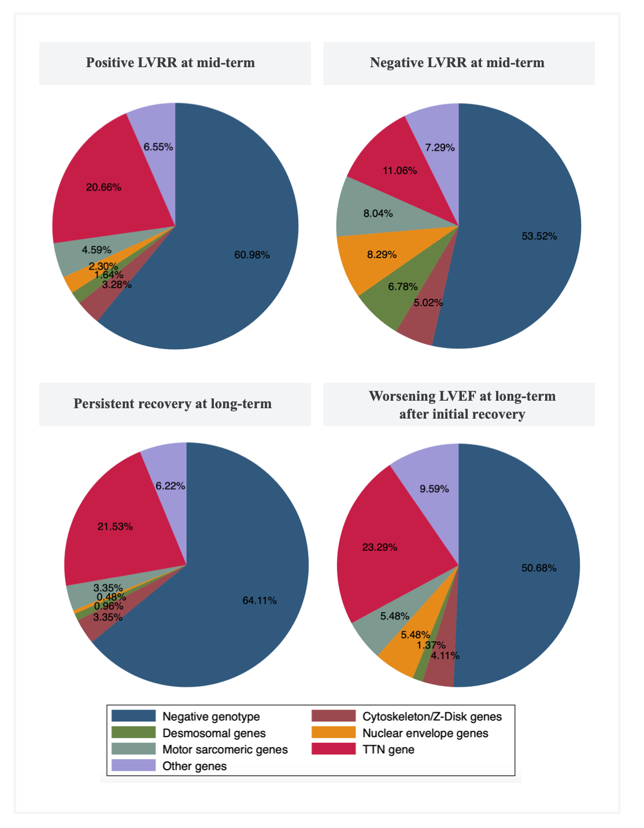
Figure S1. Distribution of genes according to the functional gene group and left ventricular reverse remodelling at mi-d and long-term.
Corrección a la figura 1
Cambiar “Z-Disk” a “z-disk”

Figure S2. Distribution of genes according to the functional gene group in patients with an initial complete recovery
Corrección a la figura 2
Cambiar “Z-Disk” a “z-disk”

